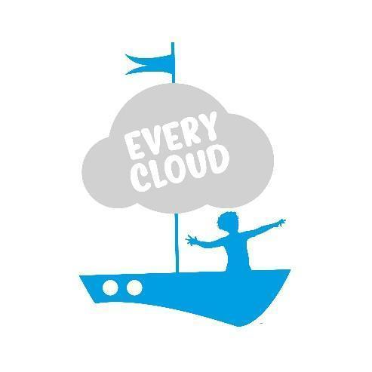
Every Cloud Play & Creative Arts Therapy

Safeguarding Adults at Risk
Policy & Procedures

Designated Safeguarding Lead: Naomi Murray

Deputy Designated Safeguarding Lead: Kay Tibbles

Date Approved: November 2025
November 2026

Contents
1. Overview 3
1.1 Introduction 3
1.2 Scope 4
1.3 Policy Objectives 5
1.4 Legal & Regulatory Framework 7
1.5 Safeguarding Practice 8
1.6 Standards of Conduct 13
1.7 Communication 14
2. Safeguarding Adults at Risk 15
2.1 What is Safeguarding 15
2.2 Safeguarding Definition 16
2.3 Clinical & Professional Supervision 16
2.4 Recognising Abuse & Safeguarding Concerns 16
2.5 What Defines Abuse 17
2.6 Examples of Abuse 19
2.7 Online Safety & Digital Risk Considerations 22
2.8 Missing Persons 23
3. Assessing & Supporting Safeguarding Concerns 24
3.1 Managing Disclosure 24
3.2 Resources 25
3.3 Safeguarding Reporting Procedure 26
3.4 Safeguarding and Data Protection 29
4. Allegations about a Therapist 30
4.1 What is an Allegation: 30
4.2 Steps to Take 30
4.3 Further Escalation 31
Appendix 1: Concern Log 1
Appendix 2: Safeguarding procedure Flow Chart 2

1. Overview

1.1 Introduction
Safeguarding is a term used in the United Kingdom and Ireland to denote measures to protect the health, well-being and human rights of individuals, which allow people — especially children, young people and adults at risk — to live free from abuse, harm and neglect.
Every Cloud Play & Creative Arts Therapy CIC (hereafter referred to as Every Cloud), take their safeguarding responsibilities seriously at all times. This policy sets out our processes to meet our six key practice aims and our ethos in regard to safeguarding practice including the procedures we follow in the event of a safeguarding concern; either low level, a more serious concern or disclosure.
Every Cloud also follows six key practice aims in relation to our work with children, young people and vulnerable adults:
- Understanding the child, young person and/or adults at risk’s daily life
- Ability to work with families with reluctant engagement
- Demonstrate critical thinking and challenge at all times
- Respond to changing risks and needs of the client’s vulnerability
- Share information in a timely and appropriate way whilst maintaining client confidentiality in accordance with Every Cloud policies and procedures
- Demonstrate clear and consistent organisational leadership and promote our culture for good outcomes for our clients

1.2 Scope
Our safeguarding policies and procedures, specific to our role as children and young people’s therapists (with our client base solely in the age 3-17 age group), are covered in our Safeguarding Children and Young People Policies and Procedures.
However, Every Cloud has a commitment to safeguard and protect the welfare of all who use our services and we recognise that:
- We engage with children and young people’s families and carers who may be adults at risk
- Some of our client base are transitioning to adulthood thereby potentially being exposed to different safeguarding risks and may become adults at risk after leaving our service
Therefore this policy outlines the safeguarding risks and associated policies and procedures for these groups of potential adults at risk.
This Policy must be read and operated in conjunction with Safeguarding Children and Young People Policies & Procedures (November 2025).
This policy and its procedures apply to all Every Cloud staff and volunteers: it is important that everyone at Every Cloud, whether paid or not, is aware of safeguarding risks and the appropriate steps to take if there are indications that an adult at risk may be exposed to harm.

1.3 Policy Objectives
Our child-centred and person-centred therapeutic approach underpins all our work with children and young people. Objectives that are specific to our safeguarding ethos are:
- To support children, young people and adults at risk in ways that will foster security, confidence and independence
- To provide an environment in which children, young people and adults at risk feel safe, secure, valued and respected, and feel confident to disclose to their therapist if they are in or have had difficulties, believing they will be effectively listened to. Every Cloud recognises that children may not feel ready or know how to tell someone if they are being abused and that often building a safe, therapeutic relationship needs to be the initial priority.
- To be clear and transparent with our confidentiality contract with each child, young person and adult at risk that confidentiality cannot be maintained if the therapist believes there is a risk of harm to anyone. This will be discussed with the child or young person at the start of their therapy intervention and again at the time of the disclosure.
- To raise the awareness of all therapists (including those therapists and professionals working elsewhere but supported by Every Cloud supervision) of their duty to safeguard children and young people and adults at risk and of their responsibilities in identifying and reporting possible cases of abuse.
- To emphasise the need for good levels of communication between parents/carers and all agencies, enabling the therapist to have a clear picture of the situation, considering all parts of the jigsaw and the role that information sharing can play in pulling together all pieces of the puzzle.
- To develop a structured procedure within Every Cloud which will be followed in cases of suspected abuse or concerns, also referred to as low level concerns (see Appendices One & Two).
- To develop and promote effective working relationships with other agencies to ensure a systemic approach, especially schools, the Police; Social Care; CAMHS; Families First and their commissioned services.
- To ensure that all therapists and office staff are recruited following Safer Recruitment processes and have suitability checks, including verification of their identity, qualifications and a satisfactory Enhanced DBS and online check (according to guidance) and a single central record (SCR) is kept updated regularly.
See also Safer Recruitment Policy
- To ensure that all therapists receive all relevant statutory Safeguarding/Child Protection/Prevent training and Designated Safeguarding Leads receive relevant enhanced training.
- To ensure all therapists are aware of their duty to report in cases of Prevent and suspected FGM.

1.4 Legal & Regulatory Framework
Our safeguarding policy and our practice reflects current legislation and guidelines including but not limited to:
- BAPT Ethical Framework
- The Care Act 2014
- The Mental Health Capacity Act 2005
- Human Rights Act 1998
- Additional Health Needs Guidance
- Prevent Duty Guidance (2025)
- UK Data Protection Act 2018 & UK General Data Protection Regulation (UK GDPR)
- Domestic Abuse Act 2021
- Online Safety Act 2025

1.5 Safeguarding Practice
To meet these aims and objectives Every Cloud will:
- Appoint a Designated Safeguarding Lead (Naomi Murray) and a Deputy Designated Safeguarding Lead (Kay Tibbles). These roles share responsibility for maintaining safeguarding practice in line with current legislation and this policy. Regular enhanced training and attendance at (GSCP or privately arranged equivalent) update training is part of the role’s responsibility.
- Every Cloud operate a Safer Recruitment Process in all aspects of therapist, volunteers and staff recruitment. Covered in more detail in our Safer Recruitment Policy this process is a robust, inquisitive approach to recruiting. Applicants complete a role specific application form, references (2 minimum) are sought prior to interview, gaps in employment and/or questions raised from references are explored during interview and suitability checks included Enhanced DBS are also carried out. Fully qualified therapists must be accredited by their Professional body, registered with the PSA and work to their ethical principles. Student therapists must be training towards this accreditation.
- Every Cloud will ensure that all therapists, other than DSL/DDSL receive Safeguarding Training at least every 3 years. DSL and DDSL receive Multi agency training every 2 years.
- Every Cloud also include Prevent training within their regular CPD and are both Prevent aware and FGM aware in their practice, understanding the importance of reporting such concerns. Page 159 of KCSIE 2025 details links to training, resources and further guidance around Prevent and Channel referrals. Referrals to the Prevent team can be made here or by emailing the Gloucestershire Prevent Team on Prevent@gloucestershire.pnn.police.uk In Gloucestershire the Prevent team are a Gloucestershire constabulary team.
- Families who have experienced the complexities of the Toxic Trio—mental ill-health, substance misuse, and domestic abuse—or other high levels of adversity, often referred to as Adverse Childhood Experiences (ACEs), are at significantly greater risk of ongoing harm and intergenerational trauma. Every Cloud’s BAPT Registered Play Therapists®, with their specialist training in child development, trauma-informed practice, and therapeutic play interventions, are uniquely equipped to support these families. Their expertise enables them to create safe, attuned therapeutic environments that foster emotional regulation, resilience, and recovery for children and their caregivers.
- Every Cloud will sign up to GSCP & South West Prevent alerts and include Safeguarding updates as an agenda item in monthly Team meetings. All therapists are encouraged to also sign up to GSCP & Prevent alerts on their individual @everycloudtherapy email addresses.
- Every Cloud will hold a single central record (SCR) detailing each therapist’s verified information of their ID, qualification, Enhanced DBS Checks and training dates. Therapists are also Paediatric First Aid trained every 3 years. This SCR will be regularly updated by our Business Support Administrator.
- In the initial meeting with parents/carers and in our initial session with each new client we will inform them, communicating in a way that they can understand, our confidentiality agreement and the exception for safeguarding concerns. This will also be reiterated as the therapeutic intervention progresses as the therapist feels necessary.
- Every Cloud will review this policy at least annually. This may be more frequent if updated guidance or legislation is produced or if ‘lessons learnt’ deem an amendment. Part of the review process includes regular in-house training, delivered by the DSL and policy author to all staff, volunteers and therapists cascading the updated policy in addition to regular team discussions and case study scenarios across our in house training programme.
- Every Cloud will ensure that the safeguarding policy and procedure is available on our website and a written copy available in our policy folder.
- Every Cloud will develop effective links with relevant agencies and cooperate as required with their enquiries, ensuring that therapists attend case conferences, core groups and other multi-agency planning meetings where possible. On request and in keeping with our client confidentiality procedure and GDPR policy we will contribute to assessments and reports where appropriate.
- Every Cloud Play understand and will follow the Gloucestershire Safeguarding Adults Board Multi-Agency Policy and Procedures.
- Every Cloud will keep written records of low-level concerns about adults at risk called a Concern Log (Appendix 1). This is used to help build up a picture of what might be happening for the adult at risk. We will use the practice of respectful challenge and our ethical right to share information with the intention to protect where necessary. All Concern Logs started are discussed initially and then at regular intervals with the DSL at Every Cloud and where necessary contribute to a referral to the Gloucestershire Safeguarding Adults Board (refer Section 3) or seek support from other agencies.
- Every Cloud believe that effective working together depends on a culture of open and honest relationships between agencies and professional differences are welcomed by professionals who want the best service for children, young people and their families/carers in Gloucestershire. Every Cloud agree that problem resolution is an integral part of professional co-operation and joint working to safeguard adults at risk in Gloucestershire. Disagreement based on a passion to improve outcomes for adults at risk is healthy professional practice although resolution of disagreement is an integral part of professional cooperation and joint working to safeguard adults at risk. Effective working together is dependent on an open and honest relationship between agencies and professionals. Where necessary and identified Every Cloud will utilise the Escalation of Professional Differences Guidance Every Cloud will ensure all records are kept securely and confidentially, as per our client confidentiality procedure and privacy statement.
See also Data Protection Policy.
- Every Cloud will ensure that the therapy rooms, office and building they operate from is regularly risk assessed to maintain a safe and secure environment and appropriate insurances and checks are in place.
- Every Cloud will ensure that there is an appropriate lone working policy
See also Health and Safety Policy

1.6 Standards of Conduct
Every Cloud ensures that therapists conduct themselves in a fully professional manner in all aspects of their role.
Each therapist works to and within the Core Competencies and Ethical Basis for Good Practice as set out by BAPT; their registered body. Comprehensive details of the BAPT Core Competencies can be found here.

1.7 Communication

As part of our work it is essential that we communicate with all who use our service, including parents and carers in a way they understand, sing language and methods that inclusive of gender, race and disability or communication differences. This includes all verbal and written communication, as well as posters and physical materials at Every Cloud.
It is essential that a person’s preference for how they are referred to in name and pronoun is identified with them from the beginning and used consistently with them and about them in all communications.
There are specific requirements around mental capacity and communication which are detailed in Section 3.

2. Safeguarding Adults at Risk

2.1 What is Safeguarding
Safeguarding is the action we take to protect the human right to live a life that is free from abuse and neglect. The objective of safeguarding adults at risk is to promote their welfare to enable them to retain independence, wellbeing and choice. The six principles of safeguarding, defined by the Care Act (2014), are:
• Empowerment: Children and Adults at Risk being supported and encouraged to make their own decisions and give informed consent.
• Prevention: It is better to take action before harm occurs.
• Proportionality: The least intrusive response appropriate to the risk presented.
• Protection: Support and representation for those in greatest need.
• Partnership: Local solutions through services working with their communities. Communities have a part to play in preventing, detecting and reporting neglect and abuse.
• Accountability: having a visible policy and statement of intent helps everyone in the organisation recognise their own accountability in the protection from and avoidance of abuse or harm.
Safeguarding should be a coordinated approach and is everyone’s responsibility.

2.2 Safeguarding Definition
According to the Care Act (2014), an adult at risk (vulnerable adult) is a person who: Has care and support needs, whether or not the Local Authority e.g. Gloucestershire County Council (GCC) is meeting any of those needs and as a result of those care and support needs is unable to protect themselves from abuse or neglect or the risk of it. An adult is legally defined as a person over the age of 18 years old.

2.3 Clinical & Professional Supervision
Every Cloud also offers Clinical and Professional Supervision. The staff members undertaking this role are fully aware of the implications of safeguarding responsibilities that are held when supporting other therapists to fully support their clients. Where necessary and identified Every Cloud Supervisors will ensure that current best practice in regard to safeguarding policy and procedure is at the forefront of decisions made and advice given in clinical and professional supervision sessions.

2.4 Recognising Abuse & Safeguarding Concerns
At Every Cloud we appreciate the position of trust that we, as therapists have in working with and supporting young people and their parents and carers. We follow a child centred and person- centred approach in all aspects of our work and our paramount principle in regard to safeguarding is to use enquiring minds: challenging or questioning anything that might need further information.

2.5 What Defines Abuse

For adults at risk, abuse is defined as a violation of an individual’s human and civil rights through acts of harm, harassment, neglect, or exploitation. It can be a single act, repeated acts, or a pattern of behaviour that causes significant harm or distress. This includes both actions that directly cause harm and failures to act to prevent harm.
Abuse can occur in any setting — including a person’s own home, residential or nursing care, supported living, day services, workplaces, online spaces, or in the wider community. It can be carried out by family members, carers, professionals, volunteers, acquaintances, or strangers.
Abuse can happen face-to-face, entirely online, or through technology being used to facilitate offline abuse.
Adults at risk may be more vulnerable to certain types of abuse due to factors such as:
- Physical or cognitive impairments
- Poor mental health/low emotional wellbeing
- Communication barriers
- Social isolation or lack of accessible support
- Dependence on others for personal care or financial management
- Discrimination relating to disability, age, race, religion, gender identity or sexuality
Certain groups may be disproportionately targeted. For example, LGBTQ+ adults at risk may experience homophobic, biphobic, or transphobic hate crime, as well as increased risks of sexual abuse, online exploitation, or being coerced in unsafe spaces where adequate safeguarding measures are absent.
- At Every Cloud we see families with low emotional wellbeing and mental health challenges. We recognise that some adults at risk within these families are therefore more vulnerable to online grooming/coercion or digital based risks. We work to remain curious about their online world and have regard to The Online Safety Act and current online risks, recognising that we are a generation of professionals that are largely digitally naive whilst raising and supporting digital natives.
- Adults at risk who have experienced conflict trauma or have refugee status are at greater risk of safeguarding harm because they often experience trauma, loss, and disruption to family and community support systems. Many have fled conflict, violence, or persecution, which can lead to emotional distress and vulnerability. Language barriers, unfamiliarity with local systems, and cultural differences can make it harder for them to communicate their needs or access help. In some cases, separation from parents or caregivers increases the risk of exploitation, neglect, or abuse. These combined factors make refugee adults at risk particularly vulnerable and in need of extra protection and support.

2.6 Examples of Abuse
Every Cloud understands that abuse has many guises and may include, but is not limited to:
- Physical abuse: a form of abuse which may involve hitting, shaking, throwing, poisoning, burning or scalding, drowning, suffocating or otherwise causing physical harm.
- Sexual abuse: involves forcing or enticing another person to take part in sexual activities, not necessarily involving violence, whether or not that person is aware of what is happening. The activities may involve physical contact, including assault by penetration (for example rape or oral sex) or non-penetrative acts such as masturbation, kissing, rubbing, and touching outside of clothing. They may also include non-contact activities, such as involving adults at risk in looking at, or in the production of; sexual images, watching sexual activities, encouraging them to behave in sexually inappropriate ways, or grooming them in preparation for abuse. Sexual abuse can take place online, and technology can be used to facilitate offline abuse. Sexual abuse is not solely perpetrated by adult males. Women can also commit acts of sexual abuse, as can other children or young people.
- Emotional or psychological abuse: the persistent emotional maltreatment of an adult at risk such as to cause severe and adverse effects on their wellbeing. This may include threats, humiliation, controlling or coercive behaviour, intimidation, verbal abuse, isolation, undermining of self-esteem, or denial of human and civil rights.
These may also include interactions that are beyond a person’s developmental capability as well as overprotection and limitation of exploration and learning or preventing them from participating in normal social interaction. It may involve seeing or hearing the ill-treatment of another. Some level of emotional abuse is involved in all types of maltreatment, although it may occur alone.
- Neglect: the persistent failure to meet an adult at risk’s basic physical and/or psychological needs, likely to result in the serious impairment of their health or development. This may involve a carer failing to: provide adequate food, clothing and shelter (including exclusion from home or abandonment); protection from physical and emotional harm or danger; ensure adequate supervision (including the use of inadequate care-givers); or ensure access to appropriate medical care or treatment. It may also include neglect of, or unresponsiveness to, a person’s basic emotional needs or provide inadequate emotional support.
- Financial or material abuse: the theft, fraud, misuse of property or benefits belonging to the adult at risk, coercion around wills or financial transactions, or undue pressure over financial decisions.
- Institutional abuse: poor care practice within an organisation, including lack of choice, unsafe environments, and breaches of dignity and respect for the adult at risk.
- Discriminatory abuse: harassment, slurs, or unfair treatment based on age, disability, race, religion, gender identity, sexuality, or other protected characteristics of the adult at risk.
- Domestic abuse: as recognised in the Domestic Abuse Act 2021, which includes controlling, coercive, threatening, degrading or violent behaviour between intimate partners or family members, regardless of gender or sexuality.
- Radicalisation: including being exposed to, groomed into, or coerced towards extremist beliefs or ideologies that may lead to harm to themselves or others. Radicalisation can take place in person or online and often involves manipulation, exploitation, and abuse of a person’s vulnerability, similar to other forms of grooming.

2.7 Online Safety & Digital Risk Considerations
Abuse of adults at risk can also occur through digital means and potential risks that Every Cloud staff should be aware of include:
- Online financial exploitation, including scams, fraud, or undue influence over financial decisions
- Cyberstalking, location tracking, and harassment
- Grooming and sexual exploitation via online platforms or gaming
- Coercive control within online relationships
- Exposure to extremist or radicalising content
- Manipulated media or deepfakes causing reputational or psychological harm
- AI-generated impersonation for grooming, fraud, or exploitation
- Excessive or harmful online use contributing to anxiety, isolation, or addiction
The Online Safety Act 2025 introduced stronger protections against online harm, including identity verification for adult content and monitoring requirements in certain settings. Safeguarding considerations for adults at risk must consider digital vulnerabilities — especially for those with cognitive, communication, or emotional needs.

2.8 Missing Persons

Every Cloud recognises that when an adult at risk goes missing, they may face significant danger, exploitation, or harm. Where concerns arise that an adult at risk has gone missing or is absent in unexplained circumstances, Every Cloud will follow the procedures set out in section 3.

3. Assessing & Supporting Safeguarding Concerns

Every Cloud acknowledges the role of ‘contextual safeguarding’ and will raise concerns from any aspect of the adult at risk as and when it is necessary to respectfully challenge or confirm any uncertainties regarding a person’s safety at home, or when out and about in their wider community.
Specific consideration must be given with regard to the adult at risk’s mental capacity as outlined below.

3.1 Managing Disclosure
If a safeguarding issue or disclosure arises:
- Listen carefully and remain calm.
- Make sure you understand the matter, clarifying points if needed.
- Document the main points of the conversation, including names, times, dates, specific details, and any injuries observed.
- Consider the seriousness of the harm and how imminent the risk is to the adult at risk or others
- Notify the Designated Safeguarding Lead (DSL) as soon as possible.

Every Cloud works within the Mental Capacity Act 2005 when safeguarding adults at risk. Mental capacity is the ability to make a specific decision at the time it needs to be made, which in this case is if a safeguarding concern has been identified and consideration given to if and how it is communicated (refer Section 4).
We will always assume that an adult has capacity unless it is established otherwise, and will make every effort to support individuals to make their own decisions. A person is not to be treated as unable to make a decision merely because they make an unwise decision.
Where an adult at risk is indicated to lack capacity in relation to a safeguarding decision, we will act in their best interests, using the least restrictive option available, and involve an Independent Mental Capacity Advocate (IMCA) if required. All capacity assessments and best interests decisions will be recorded in line with statutory guidance.

3.2 Resources
In assessing and supporting cases where concerns arise or are suspected the following resources may be of use:
- adult-safeguarding-decision-making-support-tool.pdf (Gloucestershire’s Safeguarding decision making support tool)
- Neglect Tool Kit
- Ted Talk Contextual Safeguarding
- Contextual Safeguarding Research Programme and Resources
- The Channel Programme (Prevent)
- Dash-without-guidance.pdf (domestic violence)
- Clare's Law (information request re a partner)
- Child Exploitation and Online Protection
- FGM Act 2003
- Self-neglect - SCIE

3.3 Safeguarding Reporting Procedure
If a therapist has a safeguarding concern it is the guidance offered in Multi agency safeguard policy and procedures | Safeguarding Adults in Gloucestershire that will be followed.
In brief, the procedure is as follows.
- All conversations about a disclosure will be recorded verbatim and kept to factual content. They will be dated, signed and kept securely. At all times, either the DSL or DDSL will be reachable at Every Cloud and any disclosures or concerns of abuse should be discussed with them in the first instance. The DSL/DDSL hold responsibility for recording all instances of alleged or reported abuse. Additional advice may also be sought from the therapist’s supervisor. If the concern warrants it the therapist may engage with other agencies involved with the adult at risk to establish further information.
The decisions made on whether the concerns are referred or not are dependent on whether the adult at risk is deemed to have capacity to make a decision about referral (and therefore either consents or not) AND if there is a legal over-ride that requires the referral to be made.
Consent to Share Information and no legal over-ride:
If consent is given by the adult at risk the following will be undertaken:
Level 1 or 2: starting a Concern Log may be appropriate. Conversations with the DSL/DDSL can assist in establishing next steps that might involve linking more closely with health or other agencies to support the adult as risk more effectively. Once a Concern Log is started the therapist and DSL will monitor on a regular basis and adjust responses accordingly.
Level 3/4: either immediately or after seeking advice the therapist will contact Gloucestershire Safeguarding Adults Helpdesk on 01452 426868, or the police if there are immediate concerns about risk of physical or sexual abuse.
The referral will be followed up in writing by Every Cloud Play & Creative Arts Therapy as soon as possible using the Adult Safeguarding Helpdesk
If you are ever concerned that an adult at risk is in immediate danger, please call the police on 999.
Consent NOT given to Share Information:
If the adult at risk is deemed to have capacity, their wishes should be respected unless there is legal over-ride not to do so.
Legal Override:
You can lawfully refer a safeguarding concern without consent if:
- Others are at risk (e.g., children in the household, other residents, staff, or members of the public).
- A serious crime has been committed (e.g., assault, sexual offence, modern slavery, financial exploitation).
- The risk is life-threatening or could result in serious harm to them or others.
- You are required by law to disclose (e.g., terrorism offences under the Prevent duty, FGM Act, court order).
- It’s in the public interest to prevent harm or crime.
The flow chart in Appendix 2, RAG rated, gives a visual representation of this process.

3.4 Safeguarding and Data Protection
Every Cloud’s commitment to complying with the UK Data Protection Act 2018 & UK General Data Protection Regulation (UK GDPR) in the way we handle and store personal information is detailed in General Data Protection Policy & Data Processing Procedures. However, it is recognised that safeguarding concerns override data protection considerations where an adult at risk may be at risk of harm.
- Where there is a safeguarding concern, staff and volunteers must follow the safeguarding reporting procedures as detailed above.
- Only information that is necessary, proportionate, and relevant to the safeguarding concern will be shared.
- All safeguarding records will be handled securely, kept confidential, and shared strictly on a need-to-know basis.
This approach ensures we balance the principles of data protection with our overriding duty to protect adults at risk from harm.

4. Allegations about a Therapist

4.1 What is an Allegation:
Please also see Complaint and Compliments Procedures.
Allegations of inappropriate behaviour, abuse or neglect means that a therapist of Every Cloud is alleged to have:
- Behaved in a way that has or may harm/ed an adult at risk
- Possibly committed a criminal offence against or related to an adult at risk
- Behaved towards an adult at risk in a way that could indicate that they are unsuitable to work with adults at risk
In respect of the above, this can include behaviour that happens outside of their professional role.

4.2 Steps to Take
Safeguarding concerns or allegations about adults at Every Cloud, whether low level or more serious should be communicated in the first instance to the Directors and Safeguarding Leads at the practice if possible. The DSL will in the first instance make a decision as to the response needed. Advice from the LADO or supervision may be sought to guide this process. Lessons learnt, even from low level concerns and cases in which concerns are not substantiated is a part of Every Cloud’s reflexive practice and our approach, in practice and in policy is adjusted and amended to ensure our safeguarding standards are of a high standard and robust in nature.
Contact details are: Naomi Murray (DSL): 07508 456372. Kay Tibbles (DDSL): 07745 277385. Contact details of Gloucestershire’s Local Authority Designated Officer (LADO) can be found here The Role of the LADO & The Allegations Management process | Gloucestershire County Council Nigel Hatten - LADO - Gloucestershire County Council . amadmin@gloucestershire.gov.uk

4.3 Further Escalation
If your concern is not rectified by Every Cloud DSL’s you may raise concerns with the local safeguarding hub. If you think that an adult is at immediate risk of significant harm you can contact the Gloucestershire Safeguarding Adults Board on 01452 426868. If you want to discuss a concern with a Community Social Worker, you can call 01452 328076.
If your concern is about a therapist’s ethical practice you can contact BAPT, the registered body for therapists working at Every Cloud Play & Creative Arts Therapy, to make a formal complaint. Use the link above or:
Chair BAPT Professional Conduct Committee
1 Beacon Mews
South Road
Weybridge
Surrey KT13 9DZ
E-mail: complaints@bapt.uk.com
If you require support to make a complaint in writing, you could ask to communicate with the Professional Conduct Committee Chair directly via e mail on complaints@bapt.uk.com or through another method if needed – please contact the BAPT office on 01932 828638 to discuss your needs.

Appendix 1: Concern Log
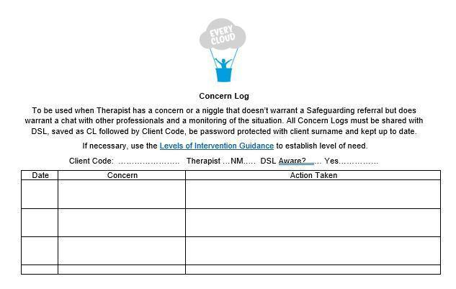

Appendix 2: Safeguarding procedure Flow Chart
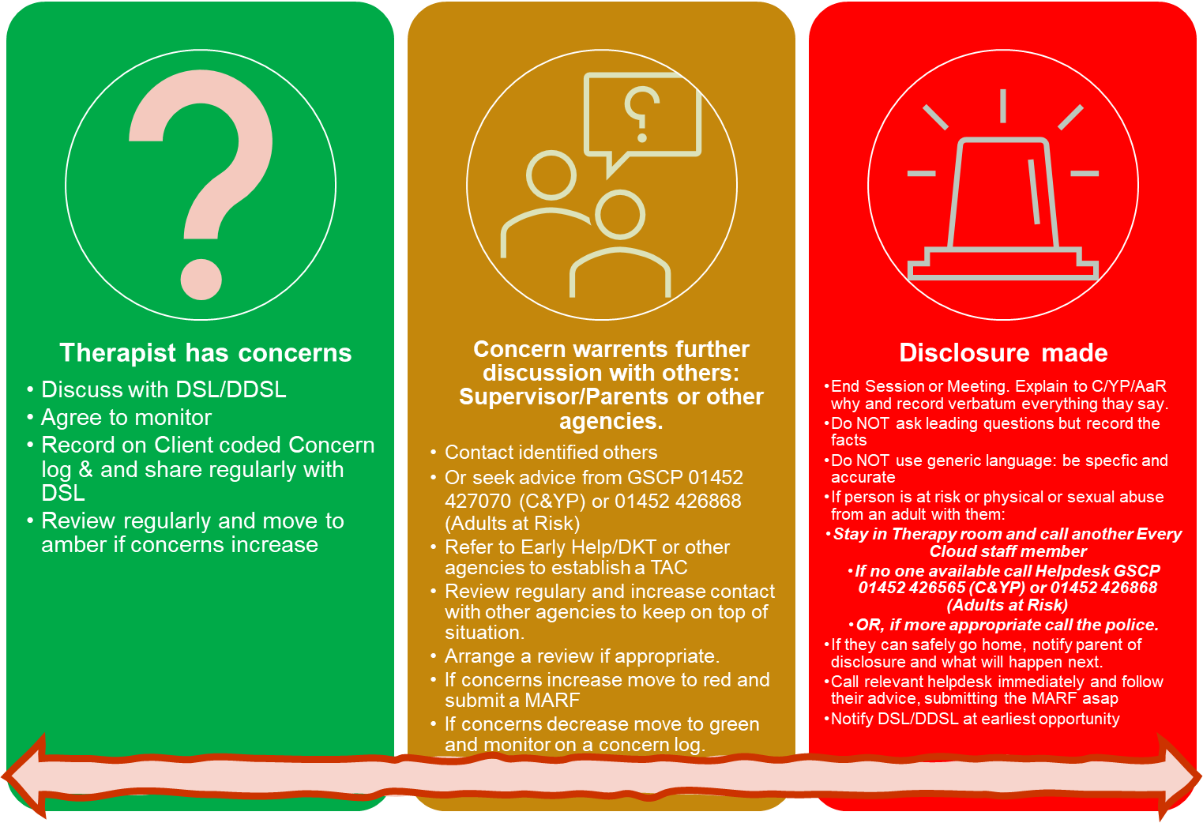
Move up and down as required, documenting your rationale throughout on the concern log and/or session notes

